**LIBRARY MANAGEMENT SYSTEM**

**A Mini Project**

**Academic Year: 2021 - 22 ODDSEMESTER**

**Department with Specialization ​: ​B.Tech., – Computer Science and** **Engineering with specialization in Artificial intelligence and machine learning**

**Semester​   :    ​I**

**Course Code​  :   ​18CSS101J**

**Course Title​​     :   ​Programming and Problem ​​​Solving**

**Submitted by**

**Swetha Suresh [Reg No: RA2111026010259]**

**Rangineni Yukthamukhi[Reg No: RA2111026010262]**

**Under the Guidance of**

**Dr. A. Suresh**

**(Associate Professor, NWC)**



**DEPARTMENT OF COMPUTING**

**COLLEGE OF ENGINEERING AND TECHNOLOGY**

**SRM INSTITUTE OF SCIENCE ANDTECHNOLOGY**

**KATTANKULATHUR- 603 203**

**JANUARY 2022**

**AIM AND ABSTRACT OF THE MINI PROJECT**

**Library management system is a project which aims in developing a computerized system to maintain all the daily work of library .This project has many features which are generally not available in normal library management systems like facility of user login and a facility of teachers login .It also has a facility of admin login through which the admin can monitor the whole system .It also has facility of an online notice board where teachers can student can put up information about workshops or seminars being held in our colleges or nearby colleges and librarian after proper verification from the concerned institution organizing the seminar can add it to the notice board.**

**It has also a facility where student after logging in their accounts can see list of books issued and its issue date and return date and also the students can request the librarian to add new books by filling the book request form. The librarian after logging into his account i.e. admin account can generate various reports such as student report, issue report, teacher report and book report.**

**Overall this project of ours is being developed to help the students as well as staff of library to maintain the library in the best way possible and also reduce the human efforts.**

**Algorithm**

**Main function**

***Steps***

1. Start with welcome screen

2. Get password from user

3. Check password. Is password correct

* Yes:-goto step 4
* No:-print wrong message and goto step 2

4. Display mainmenu as below

* *1.add books*
* *2.delete books*
* *3.search books*
* *4.issue books*
* *5.view book list*
* *6.edit book's record*
* *7.close application*

5. Get choice from user

* Choice:-1 call function addbook
* Choice:-2 call function deletebook Choice:-3 call function searchbook
* Choice:-4 call function Issuebooks
* Choice:-5 call function viewbook
* Choice:-6 call function editbooks
* Choice:-7 goto step 6

6.stop

**Add book function Steps**

1.declare file pointer ‘fp’

2.display categories of book to be added

3.get option from user. Is user want to add books

* Yes:-goto step 3
* No:-go back to main menu

4. Open file 'fp' to write

3. Assign the pointer to the end of the file to write

6. get data from user

7. write input data on a file

8. close file

9 print option to add another books

* Yes:-goto step 1
* No:-go back to main menu

**Deletebook function**

***Steps***

1.get book from user to delete

2. Declare file pointer 'ft'

3.open file 'fp’ to read

4. Assign the pointer to the beginning of the file to be read

5.loop until 'End of file' is not encountered read data from file.

6.Is user input book id= book Id on a file

* Yes:-a. open 'ft' file and copy all data of 'fp' file in 'ft'tile except that data which we want to delete

b. delete 'fp’ file and rename ft file by 'fp' file name and goto step 7

* No-print error message and close file and go back to main menu

7.close file

8 print option to delete another book

* Yes:-goto stepl
* No:-go back to main menu

***Search book function***

***steps***

1.Display option for search

* 1.Search by id
* 2.Search by book name

2. Open the fie ‘fp' to read.

3. Assign the pointer to the beginning of the file to be read.

4. If option is search by id

* Get book id from user.
* Loop until 'End of file’ is not encountered read data from file.
* Is user input book id=book id on a file.

Yes:- Display all information about that book id and goto step 6

No:- Print sorry message and goto step 6

5. If option is search by book name

* Get book name from user
* Loop until 'End of file is not encountered read data from file
* Is user input book name=book name on a file

Yes:-display all information about that book and goto step 6

No:-print sorry message and goto step 7

6. Close file.

7. Display option to search another book.

* Yes:-goto step 1
* No:- go back to main menu

***Issue book function***

Steps

1. Daplay options below

* 1.Issue book
* 2 View issued book
* 3.Search issued book
* 4 Remove issued book

2. Open 'fs’ file

3. Assign the pointer to the beginning of the file to be read

4. Get choice from user

Choice-1

* a.Get book id from user
* b. Loop until "End of file is not encountered read data from file
* c. Is input book idebook id on a file
* Yes:- get student name whom book has to issue
* No:-print sorry message and goto step e
* d. Write information of student and issued data on a file
* e. Display option to issue another book
* Yes:-goto step a
* No:-goto step 5

**Choice-2**

* Loop until "End of file' is not encountered read data from file
* b.Display list of issued book with student name, issued date and return date
* Goto step 5

**Choice-3**

* Get book id from user until 'End of Sile' is not encountered read data from file
* Loop untill ‘End of file’ is not encountered please read data from file
* Is user input book id=book id on a file
* Yes:- Display student name whom book was issued
* No:-Print sorry message and goto step di

d. Display option to search another issued book

* Yes:- goto step a
* No:-goto step 5

**Choice-4**

* A.declare the file pointer 'fg'.
* B.get book Id from user to delete from issued list .
* C.Loop until 'End of file' is not encountered read data from file.
* D.Is user input book id- book Id on a file.
* Yes:- 1. open another fg file and copy all data of 'fs file in fg file except that data which we want to delete.

2. delete 'fs file and rename 'fg file by 'fs file name and go to step e.

* No:-print error message and goto step e
* E. print option to search another book
* Yes:-goto step b
* No:-goto step 6

5. Close file

6. Go back to main menu

***Viewbook function***

**Steps**

1. Open 'fs file.

2. Assign the pointer to the beginning of the file to be read.

3. Loop until "End of file is not encountered read data from file.

4. Display list of all book with complete information.

5. Show total number of books in library .

6. Close file.

7. Go back to main menu.

**Edit book function**

**Steps**

1. Get book id to be edited from user.

2. Open file 'Fs’ .

3. Assign the pointer to the beginning of the file to be read.

4. Loop until 'End of file ‘ is not encountered read data from file

5. Call function check id. Is check id=1

* Yes:-goto step 6
* No: display sorry message and goto step 7

6. a. get new data from user of that book which to be edited

b. Assign the pointer to the current position

c. overwrite the new data on old data of that book and goto step 7

* No:- Display sorry message and goto step 7

7. Close file.

8. Display option to edit another book.

* Yes:-goto step 1
* No:-goto step 8

9. Go back to main menu

**Check id function**

***Steps***

1.Assign the pointer to the beginning of the file to be read.

2. Loop until 'End of file is not encountered read data from file.

3. If user input id=id on a file.

Yes:-return value 1

No:-return value 0

This function check whether user input id already exit in a file or not.

**Get data function**

**Steps**

1. Print “Enter information below".

2. Get categories from user.

3. Get book id.

4. Call function checkid. Is checkid=0

* Yes:-goto step6
* No:-goto step 5

5. Get book name, book author name , quantity, price and rack no. where that book located from

User.

6. Go back to main menu.

This function get data from the user for all information of book.

**Password function**

**Steps**

1. Declare two string 'pass' and password=sharda'

2. Print "Enter the password".

3. Until user entered the enter key get character for user

4. Store input character in string “pass"

5. Compare two string 'pass' and 'password'. Is both equal.

* Yes:-goto step 6
* No:-print error message and goto step 2

6. Print password match message.

7. Goto main menu.

**FLOW CHART**

***Start***

**NO**

Login

**YES**

Add Books

Delete books

Search books

Issue books

View book list

Edit book’s record

Logout

***End***

**SOURCE CODE FOR MINI PROJECT**

**LIBRARY MANAGEMENT SYSTEM**

**#include<windows.h>**

**#include<stdio.h>**

**#include<conio.h>**

**#include <stdlib.h>**

**#include<string.h> //contains strcmp(),strcpy(),strlen(),etc**

**#include<ctype.h> //contains toupper(), tolower(),etc**

**#include<dos.h> //contains _dos_getdate**

**#include<time.h>**

**//#include<bios.h>**

**#define RETURNTIME 15**

**char catagories[][15]={"Computer","Electronics","Electrical","Civil","Mechnnical","Architecture"};**

**void returnfunc(void);**

**void mainmenu(void);**

**void addbooks(void);**

**void deletebooks(void);**

**void editbooks(void);**

**void searchbooks(void);**

**void issuebooks(void);**

**void viewbooks(void);**

**void closeapplication(void);**

**int getdata();**

**int checkid(int);**

**int t(void);**

**//void show_mouse(void);**

**void Password();**

**void issuerecord();**

**void loaderanim();**

**//list of global files that can be acceed form anywhere in program**

**FILE *fp,*ft,*fs;**

**COORD coord = {0, 0};**

**//list of global variable**

**int s;**

**char findbook;**

**char password[10]={"welcomesy"};**

**void gotoxy (int x, int y)**

**{**

**coord.X = x; coord.Y = y; // X and Y coordinates**

**SetConsoleCursorPosition(GetStdHandle(STD_OUTPUT_HANDLE), coord);**

**}**

**struct meroDate**

**{**

**int mm,dd,yy;**

**};**

**struct books**

**{**

**int id;**

**char stname[20];**

**char name[20];**

**char Author[20];**

**int quantity;**

**float Price;**

**int count;**

**int rackno;**

**char *cat;**

**struct meroDate issued;**

**struct meroDate duedate;**

**};**

**struct books a;**

**int main()**

**{**

**Password();**

**getch();**

**return 0;**

**}**

**void mainmenu()**

**{**

**//loaderanim();**

**system("cls");**

**// textbackground(13);**

**int i;**

**gotoxy(20,3);**

**printf("\xB2\xB2\xB2\xB2\xB2\xB2\xB2\xB2\xB2\xB2\xB2\xB2\xB2\xB2 MAIN MENU \xB2\xB2\xB2\xB2\xB2\xB2\xB2\xB2\xB2\xB2\xB2\xB2\xB2\xB2");**

**// show_mouse();**

**gotoxy(20,5);**

**printf("\xDB\xDB\xDB\xDB\xB2 1. Add Books ");**

**gotoxy(20,7);**

**printf("\xDB\xDB\xDB\xDB\xB2 2. Delete books");**

**gotoxy(20,9);**

**printf("\xDB\xDB\xDB\xDB\xB2 3. Search Books");**

**gotoxy(20,11);**

**printf("\xDB\xDB\xDB\xDB\xB2 4. Issue Books");**

**gotoxy(20,13);**

**printf("\xDB\xDB\xDB\xDB\xB2 5. View Book list");**

**gotoxy(20,15);**

**printf("\xDB\xDB\xDB\xDB\xB2 6. Edit Book's Record");**

**gotoxy(20,17);**

**printf("\xDB\xDB\xDB\xDB\xB2 7. Close Application");**

**gotoxy(20,19);**

**printf("\xB2\xB2\xB2\xB2\xB2\xB2\xB2\xB2\xB2\xB2\xB2\xB2\xB2\xB2\xB2\xB2\xB2\xB2\xB2\xB2\xB2\xB2\xB2\xB2\xB2\xB2\xB2\xB2\xB2\xB2\xB2\xB2\xB2\xB2\xB2\xB2\xB2\xB2\xB2");**

**gotoxy(20,20);**

**t();**

**gotoxy(20,21);**

**printf("Enter your choice:");**

**switch(getch())**

**{**

**case '1':**

**addbooks();**

**break;**

**case '2':**

**deletebooks();**

**break;**

**case '3':**

**searchbooks();**

**break;**

**case '4':**

**issuebooks();**

**break;**

**case '5':**

**viewbooks();**

**break;**

**case '6':**

**editbooks();**

**break;**

**case '7':**

**{**

**system("cls");**

**gotoxy(16,3);**

**printf("\tLibrary Management System");**

**gotoxy(16,4);**

**printf("\tMini Project in C");**

**gotoxy(16,5);**

**printf("\tis brought to you by");**

**gotoxy(16,7);**

**printf("\tCode with SY Team");**

**gotoxy(16,8);**

**printf("******************************************");**

**gotoxy(16,10);**

**printf("*******************************************");**

**gotoxy(16,11);**

**printf("*******************************************");**

**gotoxy(16,13);**

**printf("********************************************");**

**gotoxy(10,17);**

**printf("Exiting in 3 second...........>");**

**//flushall();**

**Sleep(3000);**

**exit(0);**

**}**

**default:**

**{**

**gotoxy(10,23);**

**printf("\aWrong Entry!!Please re-entered correct option");**

**if(getch())**

**mainmenu();**

**}**

**}**

**}**

**void addbooks(void) //funtion that add books**

**{**

**system("cls");**

**int i;**

**gotoxy(20,5);**

**printf("\xB2\xB2\xB2\xB2\xB2\xB2\xB2\xB2\xB2\xB2\xB2SELECT CATEGOIES\xB2\xB2\xB2\xB2\xB2\xB2\xB2\xB2\xB2\xB2\xB2\xB2");**

**gotoxy(20,7);**

**printf("\xDB\xDB\xDB\xDB\xB2 1. Computer");**

**gotoxy(20,9);**

**printf("\xDB\xDB\xDB\xDB\xB2 2. Electronics");**

**gotoxy(20,11);**

**printf("\xDB\xDB\xDB\xDB\xB2 3. Electrical");**

**gotoxy(20,13);**

**printf("\xDB\xDB\xDB\xDB\xB2 4. Civil");**

**gotoxy(20,15);**

**printf("\xDB\xDB\xDB\xDB\xB2 5. Mechanical");**

**gotoxy(20,17);**

**printf("\xDB\xDB\xDB\xDB\xB2 6. Architecture");**

**gotoxy(20,19);**

**printf("\xDB\xDB\xDB\xDB\xB2 7. Back to main menu");**

**gotoxy(20,21);**

**printf("\xB2\xB2\xB2\xB2\xB2\xB2\xB2\xB2\xB2\xB2\xB2\xB2\xB2\xB2\xB2\xB2\xB2\xB2\xB2\xB2\xB2\xB2\xB2\xB2\xB2\xB2\xB2\xB2\xB2\xB2\xB2\xB2\xB2\xB2\xB2\xB2\xB2\xB2\xB2");**

**gotoxy(20,22);**

**printf("Enter your choice:");**

**scanf("%d",&s);**

**if(s==7)**

**mainmenu() ;**

**system("cls");**

**fp=fopen("Bibek.dat","ab+");**

**if(getdata()==1)**

**{**

**a.cat=catagories[s-1];**

**fseek(fp,0,SEEK_END);**

**fwrite(&a,sizeof(a),1,fp);**

**fclose(fp);**

**gotoxy(21,14);**

**printf("The record is sucessfully saved");**

**gotoxy(21,15);**

**printf("Save any more?(Y / N):");**

**if(getch()=='n')**

**mainmenu();**

**else**

**system("cls");**

**addbooks();**

**}**

**}**

**void deletebooks() //function that delete items from file fp**

**{**

**system("cls");**

**int d;**

**char another='y';**

**while(another=='y') //infinite loop**

**{**

**system("cls");**

**gotoxy(10,5);**

**printf("Enter the Book ID to delete:");**

**scanf("%d",&d);**

**fp=fopen("Bibek.dat","rb+");**

**rewind(fp);**

**while(fread(&a,sizeof(a),1,fp)==1)**

**{**

**if(a.id==d)**

**{**

**gotoxy(10,7);**

**printf("The book record is available");**

**gotoxy(10,8);**

**printf("Book name is %s",a.name);**

**gotoxy(10,9);**

**printf("Rack No. is %d",a.rackno);**

**findbook='t';**

**}**

**}**

**if(findbook!='t')**

**{**

**gotoxy(10,10);**

**printf("No record is found modify the search");**

**if(getch())**

**mainmenu();**

**}**

**if(findbook=='t' )**

**{**

**gotoxy(10,9);**

**printf("Do you want to delete it?(Y/N):");**

**if(getch()=='y')**

**{**

**ft=fopen("test.dat","wb+"); //temporary file for delete**

**rewind(fp);**

**while(fread(&a,sizeof(a),1,fp)==1)**

**{**

**if(a.id!=d)**

**{**

**fseek(ft,0,SEEK_CUR);**

**fwrite(&a,sizeof(a),1,ft); //write all in tempory file except that**

**} //we want to delete**

**}**

**fclose(ft);**

**fclose(fp);**

**remove("Bibek.dat");**

**rename("test.dat","Bibek.dat"); //copy all item from temporary file to fp except that**

**fp=fopen("Bibek.dat","rb+"); //we want to delete**

**if(findbook=='t')**

**{**

**gotoxy(10,10);**

**printf("The record is sucessfully deleted");**

**gotoxy(10,11);**

**printf("Delete another record?(Y/N)");**

**}**

**}**

**else**

**mainmenu();**

**fflush(stdin);**

**another=getch();**

**}**

**}**

**gotoxy(10,15);**

**mainmenu();**

**}**

**void searchbooks()**

**{**

**system("cls");**

**int d;**

**printf("*****************************Search Books*********************************");**

**gotoxy(20,10);**

**printf("\xDB\xDB\xDB\xB2 1. Search By ID");**

**gotoxy(20,14);**

**printf("\xDB\xDB\xDB\xB2 2. Search By Name");**

**gotoxy( 15,20);**

**printf("Enter Your Choice");**

**fp=fopen("Bibek.dat","rb+"); //open file for reading propose**

**rewind(fp); //move pointer at the begining of file**

**switch(getch())**

**{**

**case '1':**

**{**

**system("cls");**

**gotoxy(25,4);**

**printf("****Search Books By Id****");**

**gotoxy(20,5);**

**printf("Enter the book id:");**

**scanf("%d",&d);**

**gotoxy(20,7);**

**printf("Searching........");**

**while(fread(&a,sizeof(a),1,fp)==1)**

**{**

**if(a.id==d)**

**{**

**Sleep(2);**

**gotoxy(20,7);**

**printf("The Book is available");**

**gotoxy(20,8);**

**printf("\xB2\xB2\xB2\xB2\xB2\xB2\xB2\xB2\xB2\xB2\xB2\xB2\xB2\xB2\xB2\xB2\xB2\xB2\xB2\xB2\xB2\xB2\xB2\xB2\xB2\xB2\xB2\xB2");**

**gotoxy(20,9);**

**printf("\xB2 ID:%d",a.id);gotoxy(47,9);printf("\xB2");**

**gotoxy(20,10);**

**printf("\xB2 Name:%s",a.name);gotoxy(47,10);printf("\xB2");**

**gotoxy(20,11);**

**printf("\xB2 Author:%s ",a.Author);gotoxy(47,11);printf("\xB2");**

**gotoxy(20,12);**

**printf("\xB2 Qantity:%d ",a.quantity);gotoxy(47,12);printf("\xB2"); gotoxy(47,11);printf("\xB2");**

**gotoxy(20,13);**

**printf("\xB2 Price:Rs.%.2f",a.Price);gotoxy(47,13);printf("\xB2");**

**gotoxy(20,14);**

**printf("\xB2 Rack No:%d ",a.rackno);gotoxy(47,14);printf("\xB2");**

**gotoxy(20,15);**

**printf("\xB2\xB2\xB2\xB2\xB2\xB2\xB2\xB2\xB2\xB2\xB2\xB2\xB2\xB2\xB2\xB2\xB2\xB2\xB2\xB2\xB2\xB2\xB2\xB2\xB2\xB2\xB2\xB2");**

**findbook='t';**

**}**

**}**

**if(findbook!='t') //checks whether conditiion enters inside loop or not**

**{**

**gotoxy(20,8);**

**printf("\xB2\xB2\xB2\xB2\xB2\xB2\xB2\xB2\xB2\xB2\xB2\xB2\xB2\xB2\xB2\xB2\xB2\xB2\xB2");**

**gotoxy(20,9);printf("\xB2"); gotoxy(38,9);printf("\xB2");**

**gotoxy(20,10);**

**printf("\xB2\xB2\xB2\xB2\xB2\xB2\xB2\xB2\xB2\xB2\xB2\xB2\xB2\xB2\xB2\xB2\xB2\xB2\xB2");**

**gotoxy(22,9);printf("\aNo Record Found");**

**}**

**gotoxy(20,17);**

**printf("Try another search?(Y/N)");**

**if(getch()=='y')**

**searchbooks();**

**else**

**mainmenu();**

**break;**

**}**

**case '2':**

**{**

**char s[15];**

**system("cls");**

**gotoxy(25,4);**

**printf("****Search Books By Name****");**

**gotoxy(20,5);**

**printf("Enter Book Name:");**

**scanf("%s",s);**

**int d=0;**

**while(fread(&a,sizeof(a),1,fp)==1)**

**{**

**if(strcmp(a.name,(s))==0) //checks whether a.name is equal to s or not**

**{**

**gotoxy(20,7);**

**printf("The Book is available");**

**gotoxy(20,8);**

**printf("\xB2\xB2\xB2\xB2\xB2\xB2\xB2\xB2\xB2\xB2\xB2\xB2\xB2\xB2\xB2\xB2\xB2\xB2\xB2\xB2\xB2\xB2\xB2\xB2\xB2\xB2\xB2\xB2");**

**gotoxy(20,9);**

**printf("\xB2 ID:%d",a.id);gotoxy(47,9);printf("\xB2");**

**gotoxy(20,10);**

**printf("\xB2 Name:%s",a.name);gotoxy(47,10);printf("\xB2");**

**gotoxy(20,11);**

**printf("\xB2 Author:%s",a.Author);gotoxy(47,11);printf("\xB2");**

**gotoxy(20,12);**

**printf("\xB2 Qantity:%d",a.quantity);gotoxy(47,12);printf("\xB2");**

**gotoxy(20,13);**

**printf("\xB2 Price:Rs.%.2f",a.Price);gotoxy(47,13);printf("\xB2");**

**gotoxy(20,14);**

**printf("\xB2 Rack No:%d ",a.rackno);gotoxy(47,14);printf("\xB2");**

**gotoxy(20,15);**

**printf("\xB2\xB2\xB2\xB2\xB2\xB2\xB2\xB2\xB2\xB2\xB2\xB2\xB2\xB2\xB2\xB2\xB2\xB2\xB2\xB2\xB2\xB2\xB2\xB2\xB2\xB2\xB2\xB2");**

**d++;**

**}**

**}**

**if(d==0)**

**{**

**gotoxy(20,8);**

**printf("\xB2\xB2\xB2\xB2\xB2\xB2\xB2\xB2\xB2\xB2\xB2\xB2\xB2\xB2\xB2\xB2\xB2\xB2\xB2");**

**gotoxy(20,9);printf("\xB2"); gotoxy(38,9);printf("\xB2");**

**gotoxy(20,10);**

**printf("\xB2\xB2\xB2\xB2\xB2\xB2\xB2\xB2\xB2\xB2\xB2\xB2\xB2\xB2\xB2\xB2\xB2\xB2\xB2");**

**gotoxy(22,9);printf("\aNo Record Found");**

**}**

**gotoxy(20,17);**

**printf("Try another search?(Y/N)");**

**if(getch()=='y')**

**searchbooks();**

**else**

**mainmenu();**

**break;**

**}**

**default :**

**getch();**

**searchbooks();**

**}**

**fclose(fp);**

**}**

**void issuebooks(void) //function that issue books from library**

**{**

**int t;**

**system("cls");**

**printf("********************************ISSUE SECTION**************************");**

**gotoxy(10,5);**

**printf("\xDB\xDB\xDB\xDb\xB2 1. Issue a Book");**

**gotoxy(10,7);**

**printf("\xDB\xDB\xDB\xDb\xB2 2. View Issued Book");**

**gotoxy(10,9);**

**printf("\xDB\xDB\xDB\xDb\xB2 3. Search Issued Book");**

**gotoxy(10,11);**

**printf("\xDB\xDB\xDB\xDb\xB2 4. Remove Issued Book");**

**gotoxy(10,14);**

**printf("Enter a Choice:");**

**switch(getch())**

**{**

**case '1': //issue book**

**{**

**system("cls");**

**int c=0;**

**char another='y';**

**while(another=='y')**

**{**

**system("cls");**

**gotoxy(15,4);**

**printf("***Issue Book section***");**

**gotoxy(10,6);**

**printf("Enter the Book Id:");**

**scanf("%d",&t);**

**fp=fopen("Bibek.dat","rb");**

**fs=fopen("Issue.dat","ab+");**

**if(checkid(t)==0) //issues those which are present in library**

**{**

**gotoxy(10,8);**

**printf("The book record is available");**

**gotoxy(10,9);**

**printf("There are %d unissued books in library ",a.quantity);**

**gotoxy(10,10);**

**printf("The name of book is %s",a.name);**

**gotoxy(10,11);**

**printf("Enter student name:");**

**scanf("%s",a.stname);**

**//struct dosdate_t d; //for current date**

**//_dos_getdate(&d);**

**//a.issued.dd=d.day;**

**//a.issued.mm=d.month;**

**//a.issued.yy=d.year;**

**gotoxy(10,12);**

**printf("Issued date=%d-%d-%d",a.issued.dd,a.issued.mm,a.issued.yy);**

**gotoxy(10,13);**

**printf("The BOOK of ID %d is issued",a.id);**

**a.duedate.dd=a.issued.dd+RETURNTIME; //for return date**

**a.duedate.mm=a.issued.mm;**

**a.duedate.yy=a.issued.yy;**

**if(a.duedate.dd>30)**

**{**

**a.duedate.mm+=a.duedate.dd/30;**

**a.duedate.dd-=30;**

**}**

**if(a.duedate.mm>12)**

**{**

**a.duedate.yy+=a.duedate.mm/12;**

**a.duedate.mm-=12;**

**}**

**gotoxy(10,14);**

**printf("To be return:%d-%d-%d",a.duedate.dd,a.duedate.mm,a.duedate.yy);**

**fseek(fs,sizeof(a),SEEK_END);**

**fwrite(&a,sizeof(a),1,fs);**

**fclose(fs);**

**c=1;**

**}**

**if(c==0)**

**{**

**gotoxy(10,11);**

**printf("No record found");**

**}**

**gotoxy(10,15);**

**printf("Issue any more(Y/N):");**

**fflush(stdin);**

**another=getche();**

**fclose(fp);**

**}**

**break;**

**}**

**case '2': //show issued book list**

**{**

**system("cls");**

**int j=4;**

**printf("*******************************Issued book list*******************************\n");**

**gotoxy(2,2);**

**printf("STUDENT NAME CATEGORY ID BOOK NAME ISSUED DATE RETURN DATE");**

**fs=fopen("Issue.dat","rb");**

**while(fread(&a,sizeof(a),1,fs)==1)**

**{**

**gotoxy(2,j);**

**printf("%s",a.stname);**

**gotoxy(18,j);**

**printf("%s",a.cat);**

**gotoxy(30,j);**

**printf("%d",a.id);**

**gotoxy(36,j);**

**printf("%s",a.name);**

**gotoxy(51,j);**

**printf("%d-%d-%d",a.issued.dd,a.issued.mm,a.issued.yy );**

**gotoxy(65,j);**

**printf("%d-%d-%d",a.duedate.dd,a.duedate.mm,a.duedate.yy);**

**//struct dosdate_t d;**

**//_dos_getdate(&d);**

**gotoxy(50,25);**

**// printf("Current date=%d-%d-%d",d.day,d.month,d.year);**

**j++;**

**}**

**fclose(fs);**

**gotoxy(1,25);**

**returnfunc();**

**}**

**break;**

**case '3': //search issued books by id**

**{**

**system("cls");**

**gotoxy(10,6);**

**printf("Enter Book ID:");**

**int p,c=0;**

**char another='y';**

**while(another=='y')**

**{**

**scanf("%d",&p);**

**fs=fopen("Issue.dat","rb");**

**while(fread(&a,sizeof(a),1,fs)==1)**

**{**

**if(a.id==p)**

**{**

**issuerecord();**

**gotoxy(10,12);**

**printf("Press any key.......");**

**getch();**

**issuerecord();**

**c=1;**

**}**

**}**

**fflush(stdin);**

**fclose(fs);**

**if(c==0)**

**{**

**gotoxy(10,8);**

**printf("No Record Found");**

**}**

**gotoxy(10,13);**

**printf("Try Another Search?(Y/N)");**

**another=getch();**

**}**

**}**

**break;**

**case '4': //remove issued books from list**

**{**

**system("cls");**

**int b;**

**FILE *fg; //declaration of temporary file for delete**

**char another='y';**

**while(another=='y')**

**{**

**gotoxy(10,5);**

**printf("Enter book id to remove:");**

**scanf("%d",&b);**

**fs=fopen("Issue.dat","rb+");**

**while(fread(&a,sizeof(a),1,fs)==1)**

**{**

**if(a.id==b)**

**{**

**issuerecord();**

**findbook='t';**

**}**

**if(findbook=='t')**

**{**

**gotoxy(10,12);**

**printf("Do You Want to Remove it?(Y/N)");**

**if(getch()=='y')**

**{**

**fg=fopen("record.dat","wb+");**

**rewind(fs);**

**while(fread(&a,sizeof(a),1,fs)==1)**

**{**

**if(a.id!=b)**

**{**

**fseek(fs,0,SEEK_CUR);**

**fwrite(&a,sizeof(a),1,fg);**

**}**

**}**

**fclose(fs);**

**fclose(fg);**

**remove("Issue.dat");**

**rename("record.dat","Issue.dat");**

**gotoxy(10,14);**

**printf("The issued book is removed from list");**

**}**

**}**

**if(findbook!='t')**

**{**

**gotoxy(10,15);**

**printf("No Record Found");**

**}**

**}**

**gotoxy(10,16);**

**printf("Delete any more?(Y/N)");**

**another=getch();**

**}**

**}**

**default:**

**gotoxy(10,18);**

**printf("\aWrong Entry!!");**

**getch();**

**issuebooks();**

**break;**

**}**

**gotoxy(1,30);**

**returnfunc();**

**}**

**void viewbooks(void) //show the list of book persists in library**

**{**

**int i=0,j;**

**system("cls");**

**gotoxy(1,1);**

**printf("*********************************Book List*****************************");**

**gotoxy(2,2);**

**printf(" CATEGORY ID BOOK NAME AUTHOR QTY PRICE RackNo ");**

**j=4;**

**fp=fopen("Bibek.dat","rb");**

**while(fread(&a,sizeof(a),1,fp)==1)**

**{**

**gotoxy(3,j);**

**printf("%s",a.cat);**

**gotoxy(16,j);**

**printf("%d",a.id);**

**gotoxy(22,j);**

**printf("%s",a.name);**

**gotoxy(36,j);**

**printf("%s",a.Author);**

**gotoxy(50,j);**

**printf("%d",a.quantity);**

**gotoxy(57,j);**

**printf("%.2f",a.Price);**

**gotoxy(69,j);**

**printf("%d",a.rackno);**

**printf("\n\n");**

**j++;**

**i=i+a.quantity;**

**}**

**gotoxy(3,25);**

**printf("Total Books =%d",i);**

**fclose(fp);**

**gotoxy(35,25);**

**returnfunc();**

**}**

**void editbooks(void) //edit information about book**

**{**

**system("cls");**

**int c=0;**

**int d,e;**

**gotoxy(20,4);**

**printf("****Edit Books Section****");**

**char another='y';**

**while(another=='y')**

**{**

**system("cls");**

**gotoxy(15,6);**

**printf("Enter Book Id to be edited:");**

**scanf("%d",&d);**

**fp=fopen("Bibek.dat","rb+");**

**while(fread(&a,sizeof(a),1,fp)==1)**

**{**

**if(checkid(d)==0)**

**{**

**gotoxy(15,7);**

**printf("The book is availble");**

**gotoxy(15,8);**

**printf("The Book ID:%d",a.id);**

**gotoxy(15,9);**

**printf("Enter new name:");scanf("%s",a.name);**

**gotoxy(15,10);**

**printf("Enter new Author:");scanf("%s",a.Author);**

**gotoxy(15,11);**

**printf("Enter new quantity:");scanf("%d",&a.quantity);**

**gotoxy(15,12);**

**printf("Enter new price:");scanf("%f",&a.Price);**

**gotoxy(15,13);**

**printf("Enter new rackno:");scanf("%d",&a.rackno);**

**gotoxy(15,14);**

**printf("The record is modified");**

**fseek(fp,ftell(fp)-sizeof(a),0);**

**fwrite(&a,sizeof(a),1,fp);**

**fclose(fp);**

**c=1;**

**}**

**if(c==0)**

**{**

**gotoxy(15,9);**

**printf("No record found");**

**}**

**}**

**gotoxy(15,16);**

**printf("Modify another Record?(Y/N)");**

**fflush(stdin);**

**another=getch() ;**

**}**

**returnfunc();**

**}**

**void returnfunc(void)**

**{**

**{**

**printf(" Press ENTER to return to main menu");**

**}**

**a:**

**if(getch()==13) //allow only use of enter**

**mainmenu();**

**else**

**goto a;**

**}**

**int getdata()**

**{**

**int t;**

**gotoxy(20,3);printf("Enter the Information Below");**

**gotoxy(20,4);printf("\xB2\xB2\xB2\xB2\xB2\xB2\xB2\xB2\xB2\xB2\xB2\xB2\xB2\xB2\xB2\xB2\xB2\xB2\xB2\xB2\xB2\xB2\xB2\xB2\xB2\xB2\xB2");**

**gotoxy(20,5);**

**printf("\xB2");gotoxy(46,5);printf("\xB2");**

**gotoxy(20,6);**

**printf("\xB2");gotoxy(46,6);printf("\xB2");**

**gotoxy(20,7);**

**printf("\xB2");gotoxy(46,7);printf("\xB2");**

**gotoxy(20,8);**

**printf("\xB2");gotoxy(46,8);printf("\xB2");**

**gotoxy(20,9);**

**printf("\xB2");gotoxy(46,9);printf("\xB2");**

**gotoxy(20,10);**

**printf("\xB2");gotoxy(46,10);printf("\xB2");**

**gotoxy(20,11);**

**printf("\xB2");gotoxy(46,11);printf("\xB2");**

**gotoxy(20,12);**

**printf("\xB2\xB2\xB2\xB2\xB2\xB2\xB2\xB2\xB2\xB2\xB2\xB2\xB2\xB2\xB2\xB2\xB2\xB2\xB2\xB2\xB2\xB2\xB2\xB2\xB2\xB2\xB2");**

**gotoxy(21,5);**

**printf("Category:");**

**gotoxy(31,5);**

**printf("%s",catagories[s-1]);**

**gotoxy(21,6);**

**printf("Book ID:\t");**

**gotoxy(30,6);**

**scanf("%d",&t);**

**if(checkid(t) == 0)**

**{**

**gotoxy(21,13);**

**printf("\aThe book id already exists\a");**

**getch();**

**mainmenu();**

**return 0;**

**}**

**a.id=t;**

**gotoxy(21,7);**

**printf("Book Name:");gotoxy(33,7);**

**scanf("%s",a.name);**

**gotoxy(21,8);**

**printf("Author:");gotoxy(30,8);**

**scanf("%s",a.Author);**

**gotoxy(21,9);**

**printf("Quantity:");gotoxy(31,9);**

**scanf("%d",&a.quantity);**

**gotoxy(21,10);**

**printf("Price:");gotoxy(28,10);**

**scanf("%f",&a.Price);**

**gotoxy(21,11);**

**printf("Rack No:");gotoxy(30,11);**

**scanf("%d",&a.rackno);**

**return 1;**

**}**

**int checkid(int t) //check whether the book is exist in library or not**

**{**

**rewind(fp);**

**while(fread(&a,sizeof(a),1,fp)==1)**

**if(a.id==t)**

**return 0; //returns 0 if book exits**

**return 1; //return 1 if it not**

**}**

**int t(void) //for time**

**{**

**time_t t;**

**time(&t);**

**printf("Date and time:%s\n",ctime(&t));**

**return 0 ;**

**}**

**/*void show_mouse(void) //show inactive mouse pointer in programme**

**{**

**union REGS in,out;**

**in.x.ax = 0x1;**

**int86(0x33,&in,&out);**

**}*/**

**void Password(void) //for password option**

**{**

**system("cls");**

**char d[25]="Password Protected";**

**char ch,pass[10];**

**int i=0,j;**

**//textbackground(WHITE);**

**//textcolor(RED);**

**gotoxy(10,4);**

**for(j=0;j<20;j++)**

**{**

**Sleep(50);**

**printf("*");**

**}**

**for(j=0;j<20;j++)**

**{**

**Sleep(50);**

**printf("%c",d[j]);**

**}**

**for(j=0;j<20;j++)**

**{**

**Sleep(50);**

**printf("*");**

**}**

**gotoxy(10,10);**

**gotoxy(15,7);**

**printf("Enter Password:");**

**while(ch!=13)**

**{**

**ch=getch();**

**if(ch!=13 && ch!=8){**

**putch('*');**

**pass[i] = ch;**

**i++;**

**}**

**}**

**pass[i] = '\0';**

**if(strcmp(pass,password)==0)**

**{**

**gotoxy(15,9);**

**//textcolor(BLINK);**

**printf("Password match");**

**gotoxy(17,10);**

**printf("Press any key to countinue.....");**

**getch();**

**mainmenu();**

**}**

**else**

**{**

**gotoxy(15,16);**

**printf("\aWarning!! Incorrect Password");**

**getch();**

**Password();**

**}**

**}**

**void issuerecord() //display issued book's information**

**{**

**system("cls");**

**gotoxy(10,8);**

**printf("The Book has taken by Mr. %s",a.stname);**

**gotoxy(10,9);**

**printf("Issued Date:%d-%d-%d",a.issued.dd,a.issued.mm,a.issued.yy);**

**gotoxy(10,10);**

**printf("Returning Date:%d-%d-%d",a.duedate.dd,a.duedate.mm,a.duedate.yy);**

**}**

**/*void loaderanim()**

**{**

**int loader;**

**system("cls");**

**gotoxy(20,10);**

**printf("LOADING........");**

**printf("\n\n");**

**gotoxy(22,11);**

**for(loader=1;loader<20;loader++)**

**{**

**Sleep(100);printf("%c",219);}**

**}*/**

**//End of program**

BATCH NO: V105

***Team member :***

* Swetha Suresh(RA2111026010259)
* Rangineni Yukthamukhi(RA2111026010262)

**Output screen shot**

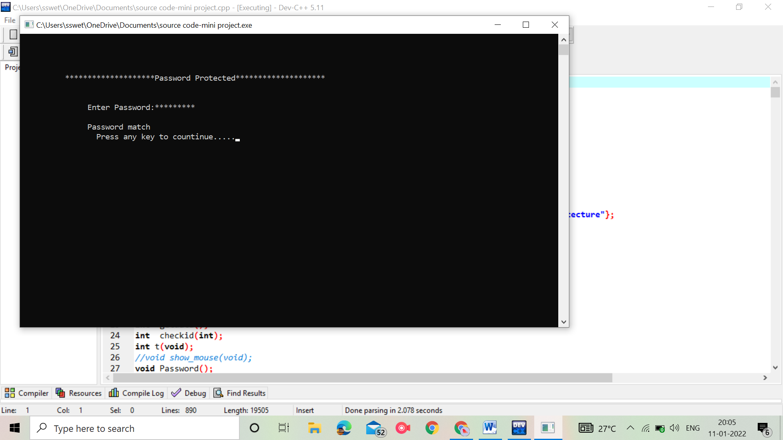

**PASSWORD PROTECTION**

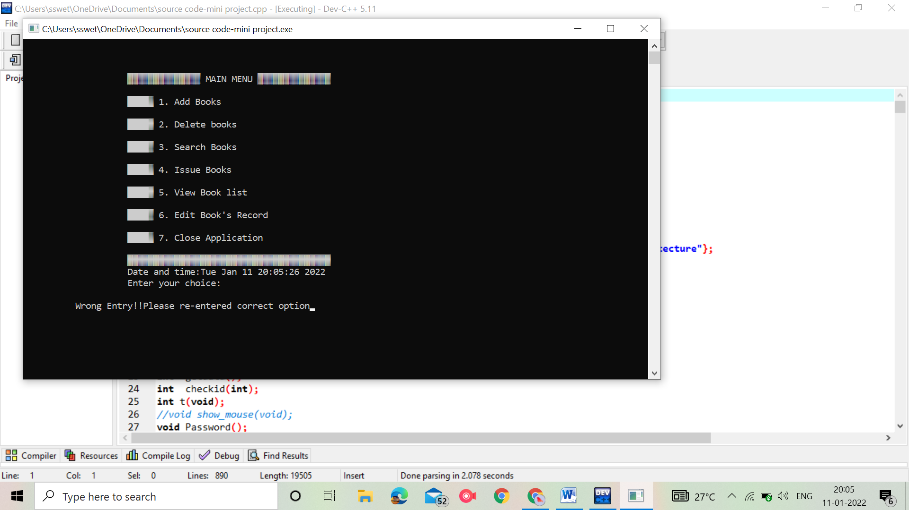

***WELCOME SCREEN***

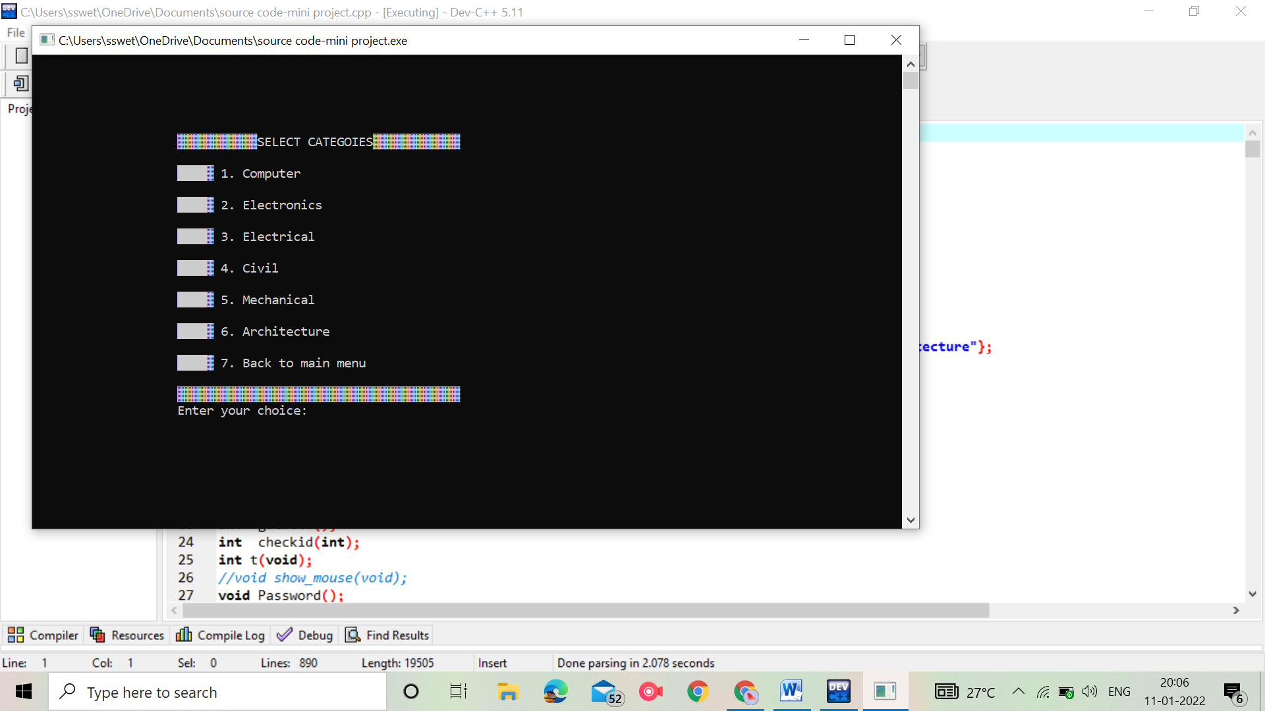

***SELECTING CATAGORIES***

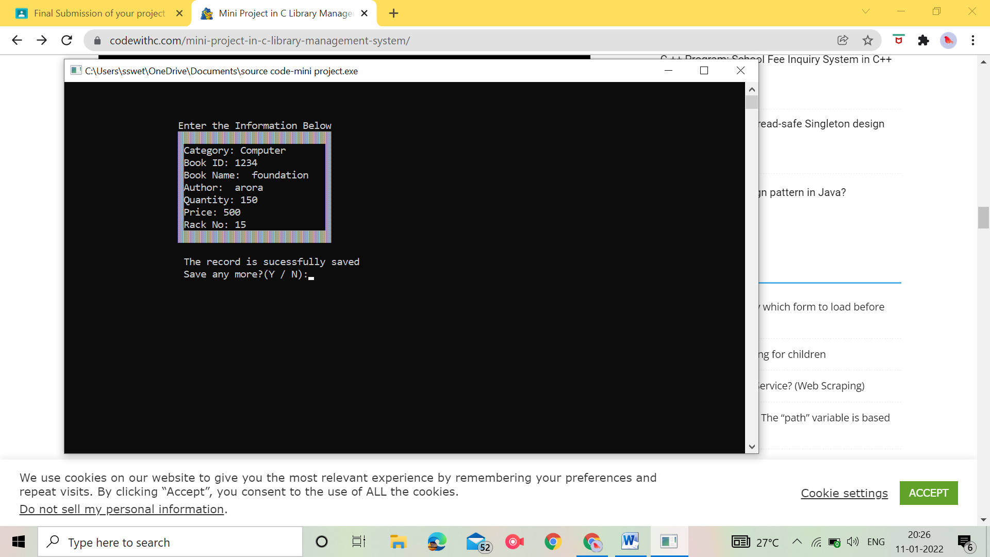

***ENTERING INFORMATIONS***

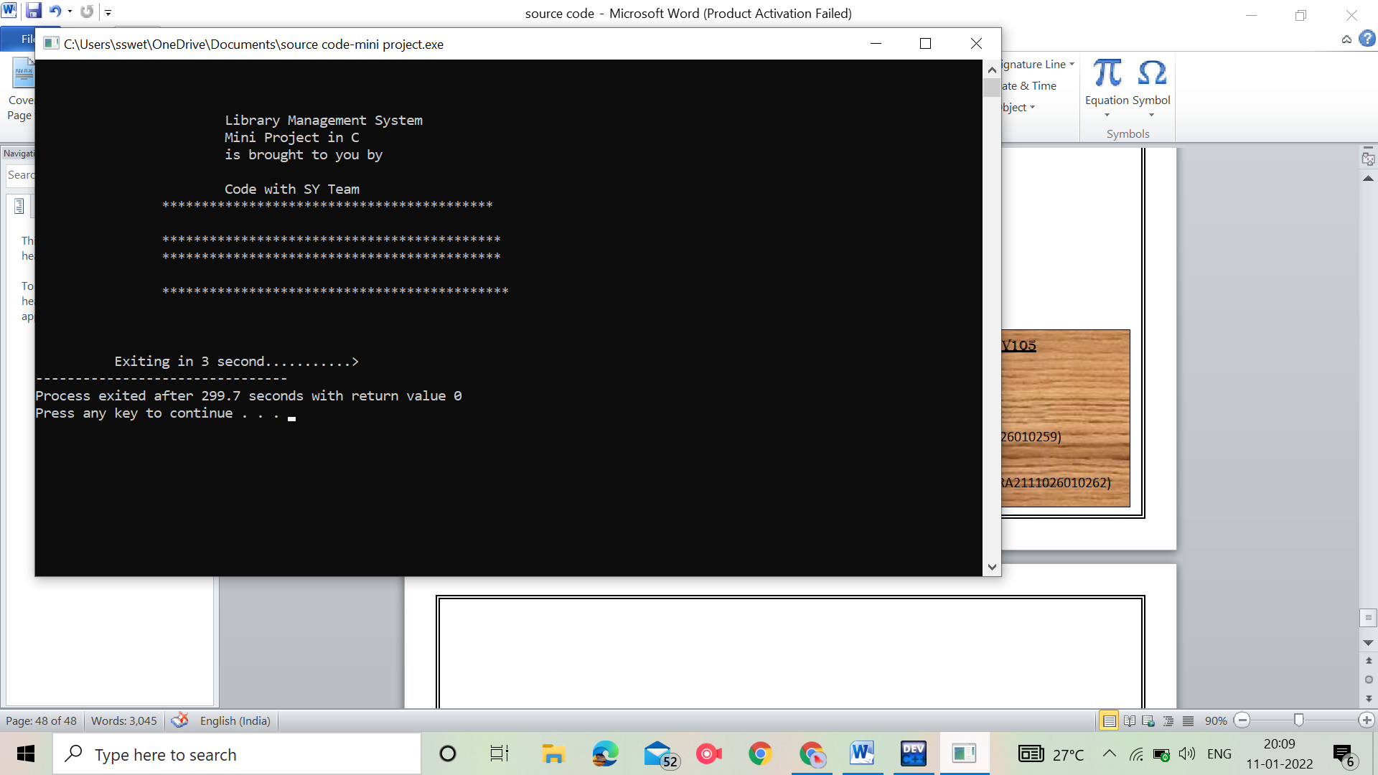

***CLOSING APPLICATION***

***RESULT & CONCLUTION*** :-

Hence after the completion of the project we got familiar with the C programming and its features. A complete and useful library management can only be developed with lot of intensive effort and time. Due to lack of time and we are beginners in programming program that we expected can't be developed by us. Our library management may not be most useful for library in our college but it will be the most useful for study and programming practice using C.

As a whole, the project has been a good learning experience for us. We have gained knowledge about the various aspects of C programming. At the same time, we have developed a deep understanding about the handling in C.

We still want to emphasize that the program is not complete by itself. There is still a lot of room improvement. Graphics may be added to program to make it more attractive. The mouse cursor may be initialized in order to make the program even more interactive.